**INDUSTRIAL TRAINING REPORT**

Under the supervision of

Mr. Maninder Singh

(Solitaire Infosys, Patiala)



Submitted in partial fulfillment of the requirement for the award of

# COMPUTER ENGINEERING

Submitted by

**NAME: GURDIT SINGH**

**NAME: AVINASH KUMAR**

**NAME: JASHANVIR SINGH**

DEPARTMENT OF COMPUTER ENGINEERING

**ACKNOWLEDGEMENT**

I’m grateful to **Mr. Maninder Singh** to give me opportunity to learn and gain knowledge at Solitaire Infosys which is considered renowned in IT sector. I thank him for the guidance he provided me to work on the project. I have taken efforts in this project.

However, the success and outcome of this project were not possible without the professional guidance of the staff at the company. I am thankful and lucky enough to get such a great opportunity to learn and develop some professional skills.

I received constant encouragement and support from the staff. I would like to extend my sincere thanks to all of them.

**INDEX**

|  |  |  |
| --- | --- | --- |
| **SNO.** | **TOPICS** | **PAGE NO.** |
| 1 | Introduction to Company | 4-6 |
| 2 | **Introduction to Technology** |  |
| Web Designing | 7-12 |
| 3 | Hardware & Software Required | 12-14 |
| 4 | Introduction to Project | 15 |
| 5 | **Glimpses of Project** | 16 |
| 7. | Future Enhancements | 17 |
| 8. | Conclusion | 18 |
| 9 | Bibliography | 19 |

**INTODUCTION TO COMPANY**

**SOLITAIRE INFOSYS**

Branch (Patiala-147001)



Fig. 1.1: Solitaire Infosys Logo

Solitaire Infosys Pvt. Ltd. is an acclaimed IT service provider contributing its part in the development of many businesses around the globe. They socialize with their clients to get a superior cognizance of their business and requirements and help them in fabricating websites and applications for their business. Founded in 2011 by a dynamic duo with the same aim and zeal, they have come a long way in satisfying their clients. They are serving our clients with the world-class services for more than seven years now. The clients are delivered with the best IT solutions after they have developed a great understanding of their business and requirements. Their team works on the client projects like its own and that is the reason why they hold the edge in the league. With every project that they deliver, they deliver their respect, creativity, quality, transparency, and teamwork to their clients. They have the experience, expertise, and capabilities to enable organizations to accelerate their service processes in every possible way.

They offer vast services in fields of UX & UI Design, Mobile Applications, Web Development, Enterprise Applications, Digital Marketing, Support & Maintenance. They also offer a good opportunity for college and universities students to attend training in their premises under the supervision of experienced staff and teachers.



Fig. 1.2: Solitaire Infosys, Mohali (Main Branch)

They are known for their excellent customer satisfaction, cost-effectiveness, and innovative skills that are unparalleled. They visualize becoming the most trusted and respected IT service provider across the globe with their vibrant, dynamic, and value-based IT solutions that revolve around their clients, team, and international standards. Solitaire Infosys Pvt. Ltd. envisions becoming a reliable partner to all its clients and focusing on doing everything ethically and rightly. They are always open to accept their mistakes and have the nerve to do the necessary changes. Solitaire Infosys helps enterprises, whether established or startups, to build and grow customer-centric digital products for mobile and web. Their clients trust their experience of over a decade and their expertise that they have gained after numerous successful deliveries in various fields. They deliver satisfactory services to their clients with an aim of helping their business in growing and reaching their organizational goals.

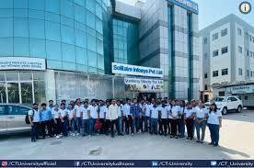

Fig. 1.3: Company’s Staff

## INTRODUCTION TO TECHNOLOGY

**WEB DESIGNING HTML** :

**HTML** stands for HyperText Markup Language. It is used to design web pages using a markup language. HTML is the combination of Hypertext and Markup language. Hypertext defines the link between web pages. A markup language is used to define the text document within the tag which defines the structure of web pages. This language is used to annotate (make notes for the computer) text so that a machine can understand it and manipulate text accordingly. Most markup languages (e.g. HTML) are human- readable. The language uses tags to define what manipulation has to be done on the text. HTML is a markup language used by the browser to manipulate text, images, and other content, in order to display it in the required format. HTML was created by Tim Berners-Lee in 1991. The first-ever version of HTML was HTML 1.0, but the first standard version was HTML 2.0, published in 1995. **HTML page structure:** The basic structure of an HTML page is laid out below. It contains the essential building-block elements (i.e. doctype declaration, HTML, head, title, and body elements) upon which all web pages are created. HTML is a technology used to make a basic structure of website. It is a client-side scripting language.

**Features of HTML:**

* It is easy to learn and easy to use.
* It is platform-independent.
* Images, videos, and audio can be added to a web page.
* Hypertext can be added to the text.
* It is a markup language.

**Why learn HTML?**

* It is a simple markup language. Its implementation is easy.
* It is used to create a website.
* Helps in developing fundamentals about web programming.
* Boost professional career.

**Advantages:**

* HTML is used to build websites.
* It is supported by all browsers.
* It can be integrated with other languages like CSS, JavaScript, etc.

**Concepts covered in HTML during training period:**

* Forms, Tables
* Text Printing tags: Font, Paragraph, Span, Heading tags, Label, Br tag, Body tag
* Lists: Ordered list, Unordered list, Definition list
* Division tag
* Media tags: Image, Video, Audio
* Html Entities: &copy; &reg; &trade; &lt; &gt; and &nbsp;
* Fieldset and Legend tags
* Anchor tag, Mark tag

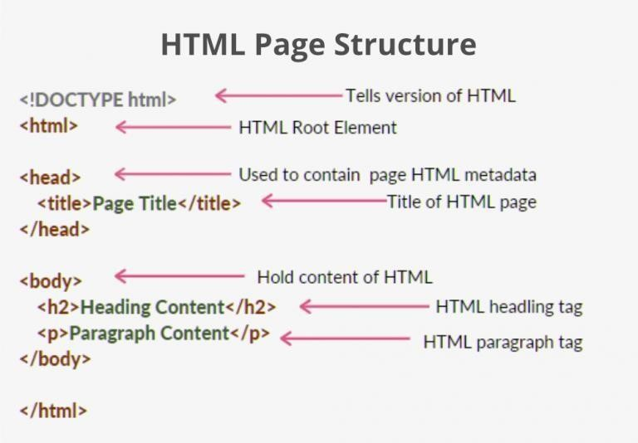

Fig. 2.1: HTML Page Structure

**CSS:**

Cascading Style Sheets, fondly referred to as CSS, is a simply designed language intended to simplify the process of making web pages presentable. CSS allows you to apply styles to web pages. More importantly, CSS enables you to do this independent of the HTML that makes up each web page. It describes how a webpage should look: it prescribes colors, fonts, spacing, and much more. In short, you can make your website look however you want. CSS lets developers and designers define how it behaves, including how elements are positioned in the browser. While html uses tags, css uses rulesets. CSS is easy to learn and understand, but it provides powerful control over the presentation of an HTML document. CSS handles the look and feel part of a web page. Using CSS, you can control the color of the text, the style of fonts, the spacing between paragraphs, how columns are sized and laid out, what background images or colors are used, layout designs, variations in display for different devices and screen sizes as well as a variety of other effects.

**Why CSS?**

* **CSS saves time:** You can write CSS once and reuse the same sheet in multiple HTML pages.
* **Easy Maintenance:** To make a global change simply change the style, and all elements in all the webpages will be updated automatically.
* **Search Engines:** CSS is considered a clean coding technique, which means search engines won’t have to struggle to “read” its content.
* **Superior styles to HTML:** CSS has a much wider array of attributes than HTML, so you can give a far better look to your HTML page in comparison to HTML attributes.
* **Offline Browsing:** CSS can store web applications locally with the help of an offline cache. Using this we can view offline websites.

**Concepts learnt:**

* It can be internal, external or inline
* Uses selectors: .class/ #id/ element name
* Pseudo classes and elements: hover, active, focus(for anchor tag)
* To change styling of first letter of any word or first line of any paragraph
* Adding content before/after any paragraph
* Float property (left/right alignment)
* Margin, padding and other basic properties

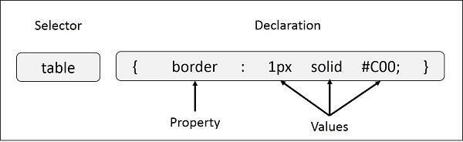

Fig. 2.2: Syntax of CSS

**BOOTSTRAP**:

Bootstrap is a free and open-source tool collection for creating responsive websites and web applications. It is the most popular HTML, CSS, and JavaScript framework for developing responsive, mobile-first websites. It solves many problems which we had once, one of which is the cross-browser compatibility issue. Nowadays, the websites are perfect for all the browsers (IE, Firefox, and Chrome) and for all sizes of screens (Desktop, Tablets, Phablets, and Phones). All thanks to Bootstrap developers -Mark Otto and Jacob Thornton of Twitter, though it was later declared to be an open-source project.

**Why Bootstrap?**

* Faster and Easier Web Development.
* It creates Platform-independent web pages.
* It creates Responsive Web-pages.
* It is designed to be responsive to mobile devices too **Concepts learnt:**
* Downloading Bootstrap libraries and linking them to our pages
* Using various inbuilt Bootstrap inbuilt designing classes for buttons, tables, form fields, images
* Downloading inbuilt templates, use them for web-development, converting them to php files and make them secure and dynamic and get data to database.

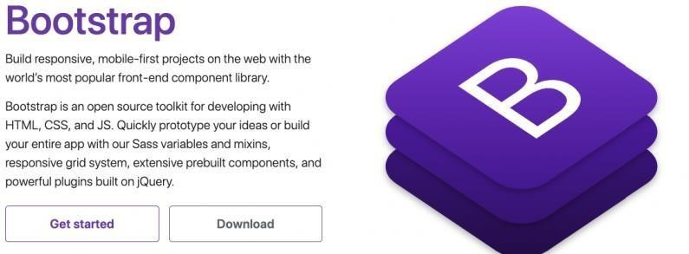

Fig.

2.3:

Bootstrap

**JAVASCRIPT**:

**JavaScript** is the world most popular lightweight, interpreted compiled programming language. It is also known as scripting language for web pages. It is well-known for the development of web pages, many non-browser environments also use it. JavaScript can be used for **Client-side** developments as well as **Server- side** developments. JavaScript is a cross-platform, object-oriented scripting language used to make webpages interactive (e.g., having complex animations, clickable buttons, popup menus, etc.). There are also more advanced server side versions of JavaScript such as Node.js, which allow you to add more functionality to a website than downloading files (such as realtime collaboration between multiple computers). Inside a host environment (for example, a web browser), JavaScript can be connected to the objects of its environment to provide programmatic control over them. It is language used to apply validations.

Fig.

2.4:

JavaScript

linking

in

HTML

file

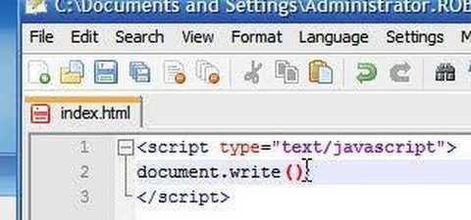

**DOM MANUPLATION**

When a web page is loaded, the browser creates a Document Object Model of the page.

The HTML DOM model is constructed as a tree of Objects:

## The HTML DOM Tree of Objects

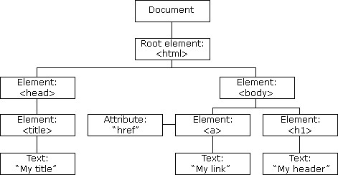

With the object model, JavaScript gets all the power it needs to create dynamic HTML:

* JavaScript can change all the HTML elements in the page
* JavaScript can change all the HTML attributes in the page
* JavaScript can change all the CSS styles in the page
* JavaScript can remove existing HTML elements and attributes
* JavaScript can add new HTML elements and attributes
* JavaScript can react to all existing HTML events in the page
* JavaScript can create new HTML events in the page

### Hardware and Software Required

**HARDWARE:**

* A system is required to type and execute the code and to store data at backend
* A pen drive to copy files there and take the backup (optional)
* A CD to export files for submission

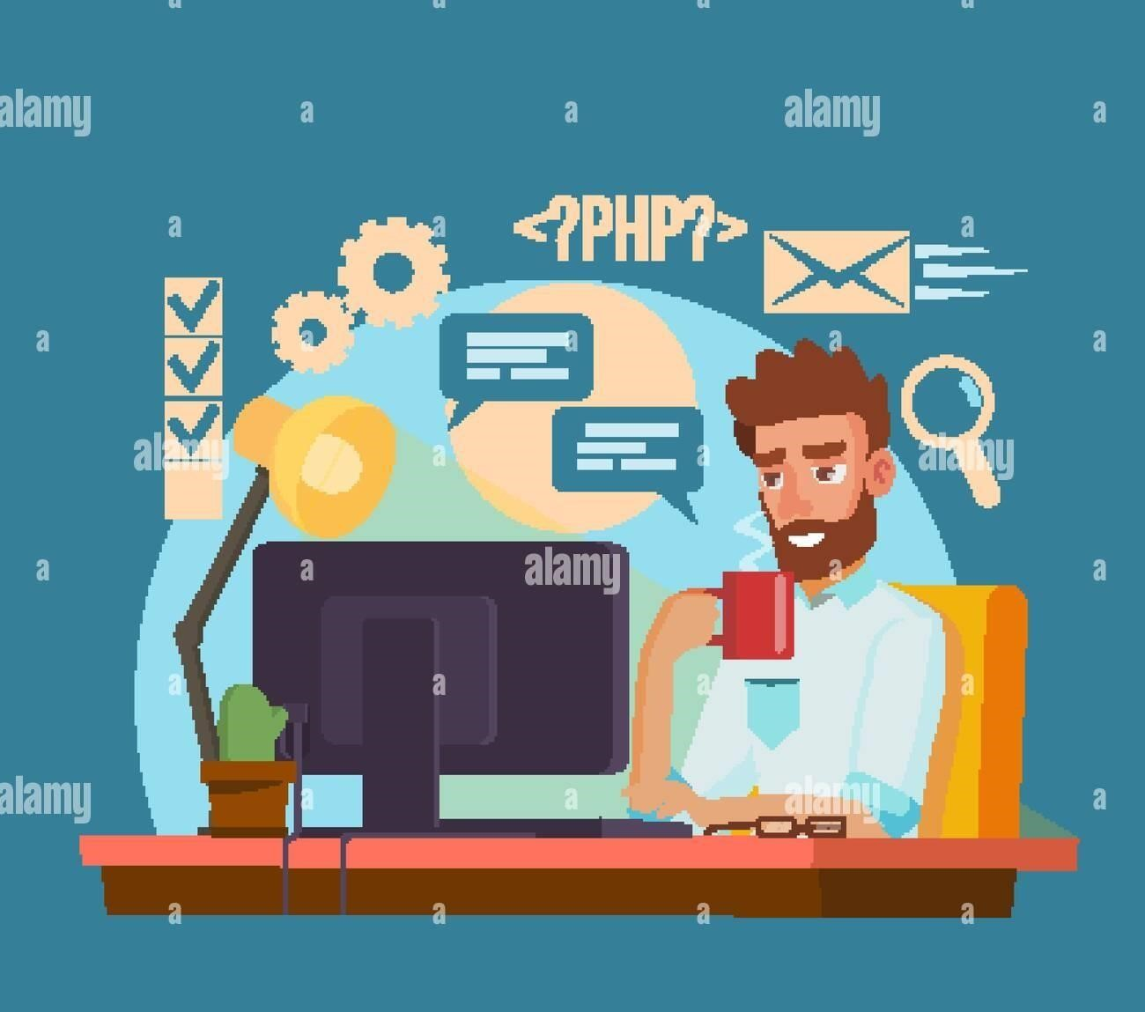

Fig. 3.1

**SOFTWARE:**

* HTML (Hypertext Markup Language)
* CSS (Cascading Style Sheets)
* BS (Bootstrap)
* JS(Javascript)

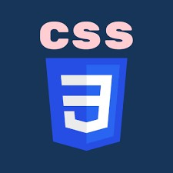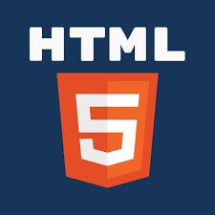

### INTRODUCTION TO PROJECT

Image search apps have revolutionized the way we discover and interact with visual content. These innovative tools utilize advanced algorithms and artificial intelligence to analyze and identify images based on user queries, enabling seamless exploration of vast image databases. Users can simply upload a photo or input keywords to find similar images, products, or information related to their search.

Moreover, image search apps enhance creativity by providing users with visual references for projects, art, or design. As technology continues to advance, these applications will likely become even more intuitive, making image discovery an integral part of our digital experience.

### PROJECT OBJECTIVES

* This app allows you to take a photo or upload an image to identify objects, landmarks, plants, animals, and more. It's great for educational purposes, shopping, and exploring.
* This is a reverse image search engine that helps you find where an image came from, how it's used, or if modified versions exist. It's useful for verifying sources or finding higher resolution versions of images.

### FEATURES

* Categories and Collections: Organize images into categories (e.g., nature, technology, people) and curated collections for easy browsing.
* User Accounts and Favorites: Enable users to create accounts to save favorite images, create collections, and track their downloads.
* Upload Functionality: Allow users to upload their own images, contributing to the community and expanding the database.
* Image Editing Tools: Integrate basic editing tools for users to adjust brightness, contrast, and apply filters directly within the app.
* Related Images Suggestions: Provide suggestions for similar images based on user searches or viewed images to enhance discovery.
* Download Options: Offer various download sizes and formats, ensuring images are available for different use cases.
* Licensing Information: Clearly display licensing information for each image, ensuring users understand usage rights.
* Community Features: Include options for commenting, liking, and sharing images, fostering a community around the content.
* Mobile Optimization: Ensure the app is fully optimized for mobile devices, providing a seamless experience across platforms.

**GLIMPSES OF PROJECT**

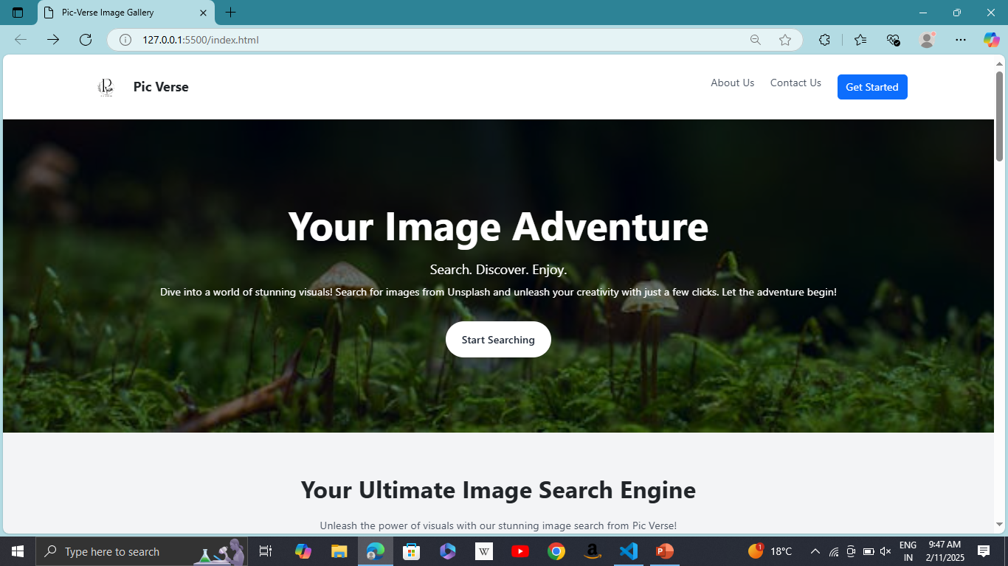

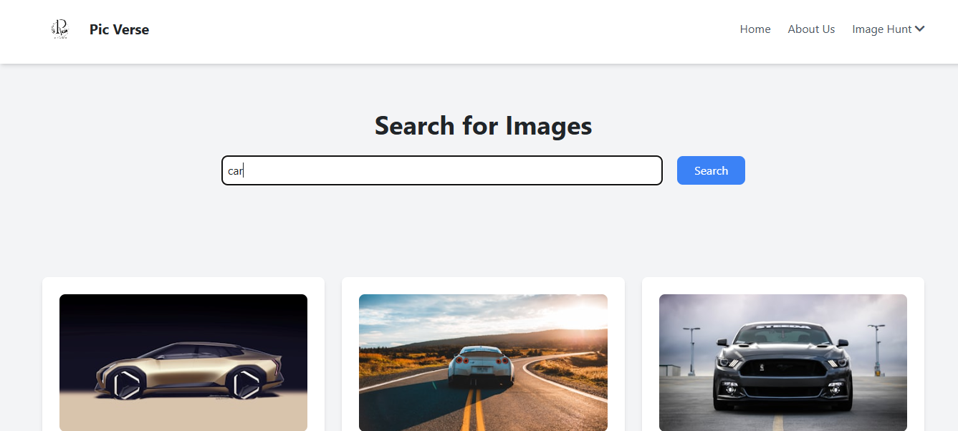

**FUTURE ENHANCEMENTS**

* Future Enhancements
* More User friendly interface.
* Implement error handling for invalid input.
* Add Login feature to save user search data.
* Customize the user interface further with additional CSS styling.

### CONCLUSION

image search app into can significantly enhance user experience and engagement. Such a feature allows visitors to easily find and identify images, products, or related content, making your site more interactive and user-friendly. By leveraging existing technologies custom solutions, you can provide valuable tools that cater to your audience's needs. This not only improves accessibility but also encourages users to explore further, ultimately driving traffic and increasing satisfaction.

**BIBLIOGRAPHY**

Template: Own idea

Pictures: <http://www.unsplash.com>

Intro to Institute: [www.infosys.com](http://www.infosys.com/)